**PROJECT – 1 :** PRODUCT LANDING PAGE

**AIM :** To create a “Product Landing Page” which provides the information regarding the variety of products over the website. This website development includes the better design and deployment of the products, About information of the company and also the services.

**SKILLS REQUIRED :** HTML, CSS, Image Editing

**EDITOR USED :** Visual Studio Code (VS Code) – Windows x64 Bit

**Coco-Cola Product Landing Page Documentation**

**Table of Contents**

1. Introduction

2. Home Page

3. Products Page

4. About Us Page

5. Contact Page

6. CSS Challenges

1. **Introduction :**

The Coco-Cola Product Landing Page project aims to create an engaging and informative website for Coco-Cola products. It consists of four main pages: Home, Products, About Us, and Contact. Each page is designed to provide specific information and functionality to the users.

1. **Home Page :**

The Home Page serves as the entry point to the website. It features a captivating hero section with a prominent Coco-Cola logo and slogan. Below the hero section, there are sections for featured products, latest promotions, and a call-to-action button to explore more.

***Design:***

- *Hero Section*: Large Coco-Cola logo with a catchy slogan overlayed on an image background.

-*Featured Products*: Grid layout showcasing popular products with brief descriptions.

- *Latest Promotions*: Carousel displaying current promotions and discounts.

- *Call-to-Action Button*: Encourages users to explore more about Coco-Cola products.

**3. Products Page :**

The Products Page showcases a variety of Coco-Cola products available for purchase. It provides detailed information about each product along with pricing and options for customization.

***Design:***

- *Product Grid*: Organized grid layout displaying various Coco-Cola products with images and descriptions.

- *Product Details*: Clicking on a product reveals more information such as ingredients, nutritional facts, and available sizes.

- *Customization Options:* Users can select different flavors and packaging options before adding products to the cart.

**4. About Us Page :**

The About Us Page provides insights into the history, mission, and values of Coco-Cola. It aims to establish a connection with the audience by sharing the brand's story and commitment to quality.

***Design:***

- *Brand History:* Timeline or storytelling format highlighting key milestones in Coco-Cola's journey.

- *Mission Statement:* Clear and concise statement outlining Coco-Cola's mission and values.

- *Team Members:* Section featuring profiles of key team members or executives.

**5. Contact Page :**

The Contact Page allows users to get in touch with Coco-Cola for inquiries, feedback, or support. It provides multiple channels for communication such as email, phone, and a contact form.

***Design:***

- *Contact Information:* Clear display of Coco-Cola's contact details including email, phone number, and address.

- *Contact Form:* User-friendly form for submitting inquiries or feedback directly through the website.

- *Social Media Links:* Links to Coco-Cola's social media profiles for additional engagement.

**6. CSS Challenges :**

While programming the CSS file for the Coco-Cola Product Landing Page, several challenges were encountered:

1. *Responsive Design:* Ensuring that the website looks visually appealing and functions well across various devices and screen sizes was a significant challenge. Media queries and flexible layouts were implemented to achieve responsiveness.

2. *Cross-Browser Compatibility:* Different browsers interpret CSS rules differently, leading to inconsistencies in the layout and appearance of the website. Testing and debugging were necessary to ensure compatibility with popular browsers such as Chrome, Firefox, Safari, and Edge.

3. *Complex Animations:* Implementing smooth animations for transitions, hover effects, and carousel slides required careful planning and optimization to prevent performance issues, especially on older devices or slower connections.

4. *Accessibility:* Ensuring that the website is accessible to users with disabilities posed a challenge. Techniques such as proper semantic HTML markup, keyboard navigation support, and appropriate contrast ratios were employed to improve accessibility.

5. *Maintainability*: As the project grows in complexity, maintaining and organizing CSS code becomes increasingly challenging. Modular CSS methodologies like BEM (Block Element Modifier) or CSS-in-JS frameworks were utilized to keep the codebase manageable and scalable.

By addressing these challenges and implementing best practices, the Coco-Cola Product Landing Page was successfully developed, providing an engaging and seamless user experience.

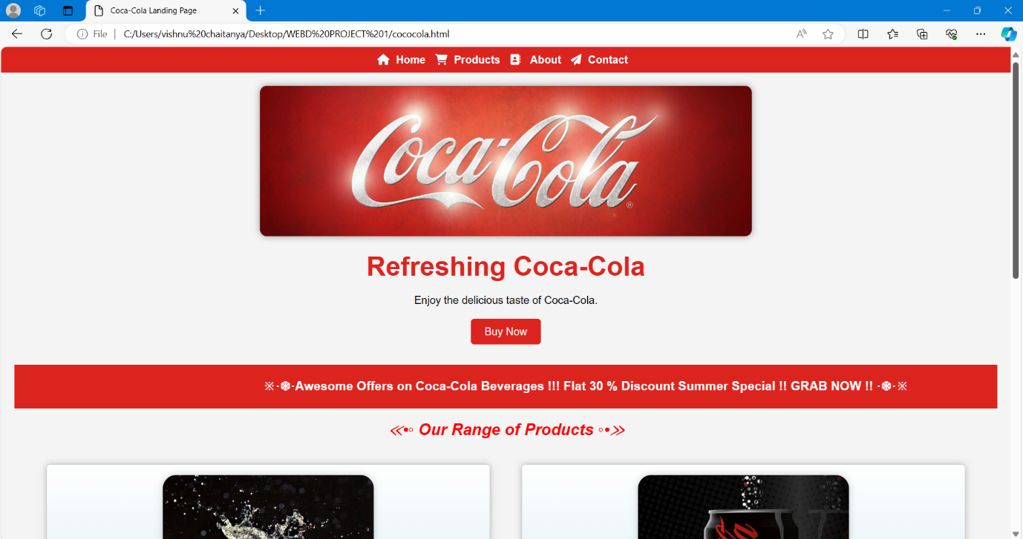**OUTPUT :**

